  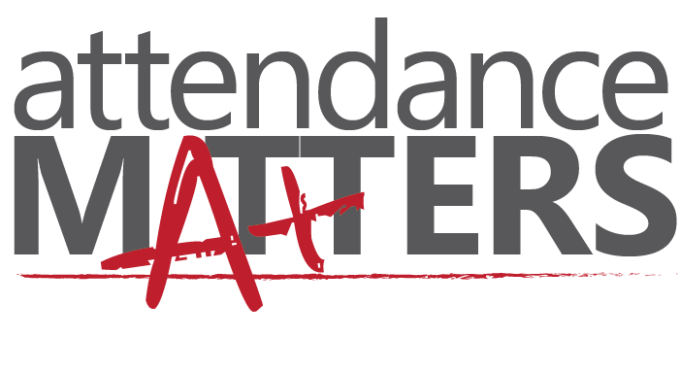
  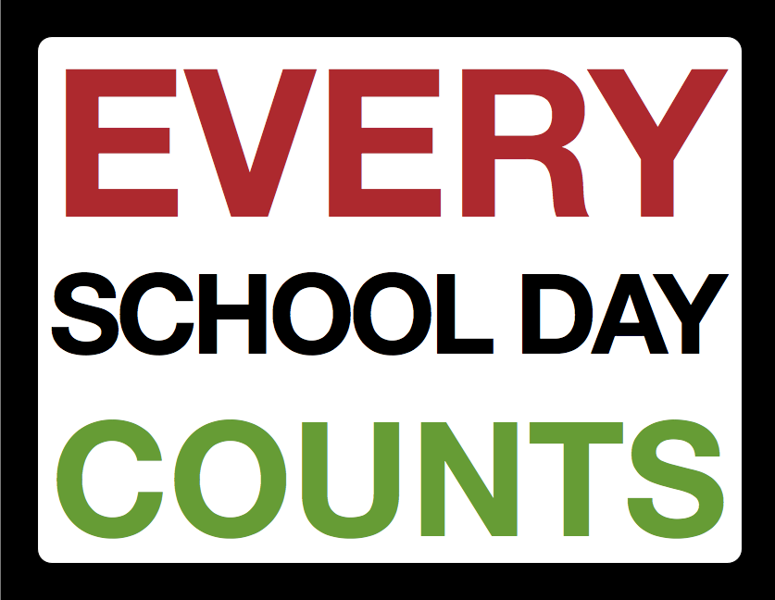
  Attend Today… Achieve Tommorow
  Attendance Matters In Macon County Schools
  
  Join us as we make a concerted effort to focus on attendance and its effect on the academic performance of students.
  Absenteeism Contributes to High School Dropout Rates
  Regular School Attendance Ensures Higher Literacy and Numeracy Rates
  Help Prepare Children for the Future
  Become a Community Partner!
  [You Have Room for Another One Here!]
  Macon County Schools
  501 S. School Street
  Tuskegee, AL 36083
  www.maconk12.org
  Dr. Karen M. Tatum, Campaign Chair
  Dr. Jacqueline A. Brooks, Superintendent of Education

